**Special Meeting Agenda: June 28th,** **2024 9:00 a.m.**

* Call to Order
* Open Tasks
  1. Hiring Process. Choose 5 for each role and schedule interviews.
  2. Grant Reporting (IDOA/NACD/NRCS Survey Aide)
     + Emily plans to finish up for this Quarter.
     + New staff will need assistance to complete these reports for the first time. Reach out to neighboring SWCDs and IDOA.
     + Binders “Survey Aide” and “NACD Grant” will provide guidance in addition to the documentation in Clinton County OneDrive.
  3. Surface Mining Report
     + Need SWCD Chairman and NRCS Signatures, report needs to be emailed by 8/15
  4. RC Verification Report
     + Needs SWCD Chairman signature, report needs to be emailed by 8/1
  5. PFC
     + Three signed contracts for FY23
       - Need NRCS to review/approve #449
       - #471 and #472 are not yet completed, construction set to begin late summer
     + There is still $$ for FY23; RC selected a potential cover crop contract to use remaining funding (#483)
     + However, none of the applications have had Board approval yet. This will need to be documented in Board Meeting Minutes at the next Board Meeting.
     + Another option is that the Board sends back the remaining FY23 funding due to lack of staff and waits to use FY24 funding until next year. Can keep applications on file, but w/o technical personnel in the office, it seems unlikely the District will be able to complete the contracts this year.
  6. NRIs
     + Required by Section 22.02a of the IL Soil and Water District Act, SWCDs must provide NRIs to the county.
     + 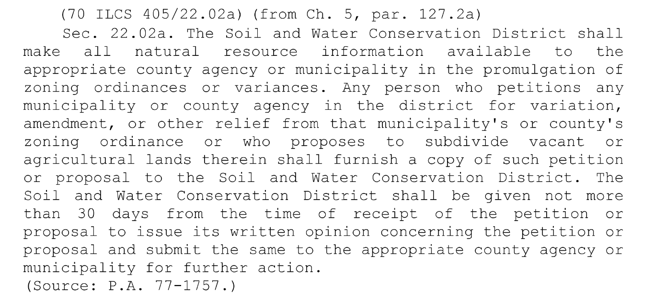
     + Without staff in the office, the District may need to contract out this work.
  7. CREP
     + Invoice submitted annually, not due until 12/31/24. Documents available at <https://dnr.illinois.gov/conservation/crep/8675309swcddocs.html>
     + Reach out to DNR for CREP Assistance
     + Only 2 CREP contracts in Clinton Co, folders are in file cabinet
  8. Upcoming Events:
     + *AISWCD Summer Conference*: As no staff are attending, it may be in the best interest of the Board to send at least one representative to the conference. Registration information is in the Gmail and available online at aiswcd.org
     + *AFT Soil Health Field Day*- received this grant (reimbursement-no funds awarded) selection; however, if there is no staff to plan the event, may need to decline. Torey Colburn emailed on 6/28/24 to verify details. Discuss at July Meeting to confirm dates and establish the field day activity. [tcolburn@farmland.org](mailto:tcolburn@farmland.org)
     + *Local Led Conservation Summit* – tentatively planned for this on 8/12 and need decision today. August/September. May need to cancel or postpone.
       - However, an in-person local-led meeting needs to be held at some point this calendar year. Discuss with NRCS if the District is unable to complete this, it becomes NRCS responsibility to conduct this meeting.
     + *Fish Sale*: Andry’s emailed the [clintoncoswcd@gmail.com](mailto:clintoncoswcd@gmail.com) email address on 6/28/24 to confirm that date for the fall fish sale. Bring up at July Board Meeting and get voted approval for the fall fish sale date and prices.
* NRCS Administrative Assistance Agreement and MOU
  1. Once new staff are hired, the Board needs to arrange a meeting with new staff and NRCS to ***clearly establish*** expectations and **ensure that all new staff have the capability to complete NRCS tasks**.
* Staff and Board Roles & Expectations
  1. **Roles need to be clearly defined for the administrative coordinator, resource conservationist, and survey aide**. Job aids will provide some guidance into this. Some tasks include more collaboration than others.
     + Some of the tasks expected of the AC are supervisory tasks. Ideally, according to the District Operational Handbook, the Board of Directors and/or an Executive Director would complete these tasks.
  2. This issue directly affects staff turnover. In past years, the AC has been functioning in a more executive role, acting as both coworker AND supervisor, which has caused friction which led to staff turnover.
  3. Another point of action is **Board involvement with District tasks and goals**. As of recent years, this Board (along with many others across the state) has taken a more “hands off” approach. This leaves staff feeling overwhelmed and frustrated with little direction.
* Benefits and Compensation
  1. As we all know, benefits and compensation are a primary issue pertaining to staff retention.
  2. The insurance is a large cost but fringe benefits from grant funds cover the cost.
  3. Some recommendations;
     + Increased leave-17.5 hours vacation is national average for non-profits, trend is 2 weeks off for all staff 1 in summer (4th of July) and 1 in winter (X-mas-NY)
     + Retirement
     + Student Loans – if positions require staff with degrees, then a student loan repayment option, even if only a set dollar amount, would attract qualified candidates. Positions at 30 hours allow staff to qualify for PSLF program.
  4. Job Security
     + The budget cuts proved to be a point of concern for many people.
     + If the District prioritized fundraising and grant writing to be self-funded, staff would feel more secure in these roles.
     + Language in annual contracts specifying performance-based raises with regular employee feedback would provide more job security.
     + Consistent COLA and incentive pay for conservation planner would be helpful to attract and retain staff.

Adjourn